#DontStopTheEducation - Remote production, recording and mixing

Wedemark, July 10, 2020 – Remote recording, mixing and production have been a part of the creation of music for a long time. But with the travel restrictions brought by Covid-19, new opportunities and the need for these services now become more evident. On July 14 at 17:00 Berlin time, hosts Andy Egerton and Tim Moore welcome five musicians and engineers to a round-table discussion, where the panel will share how they collaborate with clients to create music remotely. The hosts and panellists in this live seminar will be happy to answer your questions.

Keio Stroud (Drummer for Big and Rich), Luke Moller (String Musician and Producer), Hubert Payne (Drummer for Little Big Town), Johnny Hiland (Guitar Artist, Session Player) and Kenny Thurman (Engineer – Phil Vassar) will discuss how they initially become involved in projects of this nature, describe the challenges and their approach to recording and delivering their parts for each production.

Live Round Table

Remote production, recording and mixing
July 14, 17:00 Berlin, 16:00 London, 11:00 New York, 8:00 Los Angeles
Please register at https://zoom.us/webinar/register/WN_jsuASv5kSeKJ8_EExJi62A
The panellists of the live round table on remote production, recording and mixing: Keio Stroud, Luke Moller, Hubert Payne, Johnny Hiland and Kenny Thurman (from left to right)

For your social media channels
Join Sennheiser’s live round-table discussion on remote production, recording and mixing on July 14 at 17:00 Berlin time (11:00 New York time). #Don’tStopTheEducation

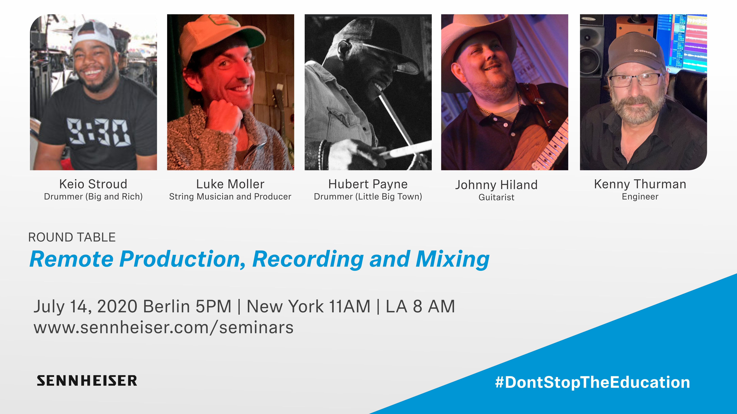 | Join Sennheiser’s live round-table discussion on remote production, recording and mixing
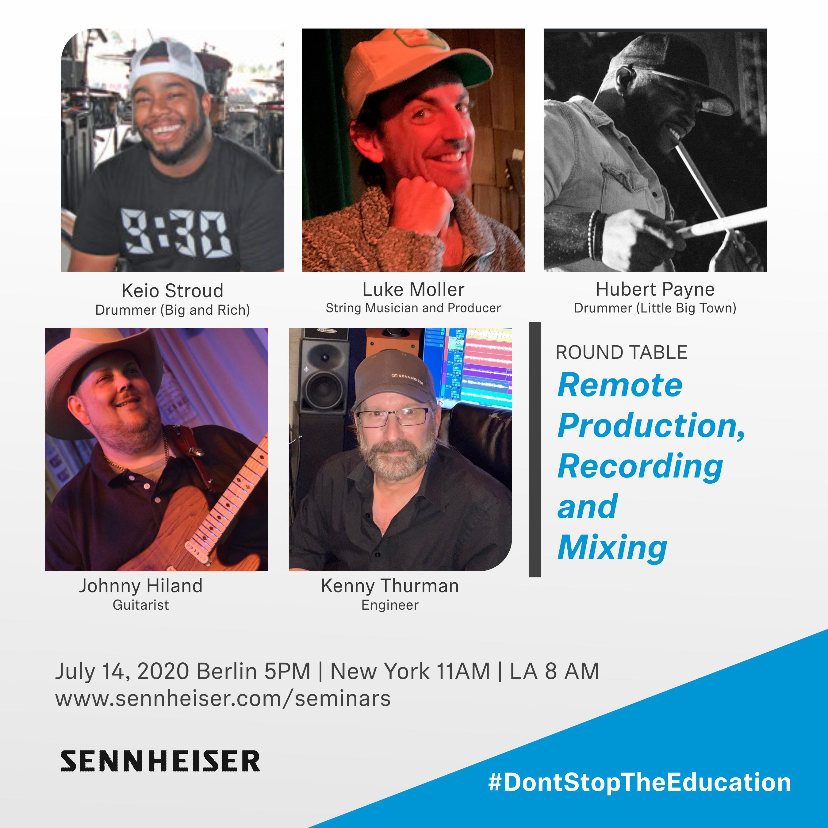 | 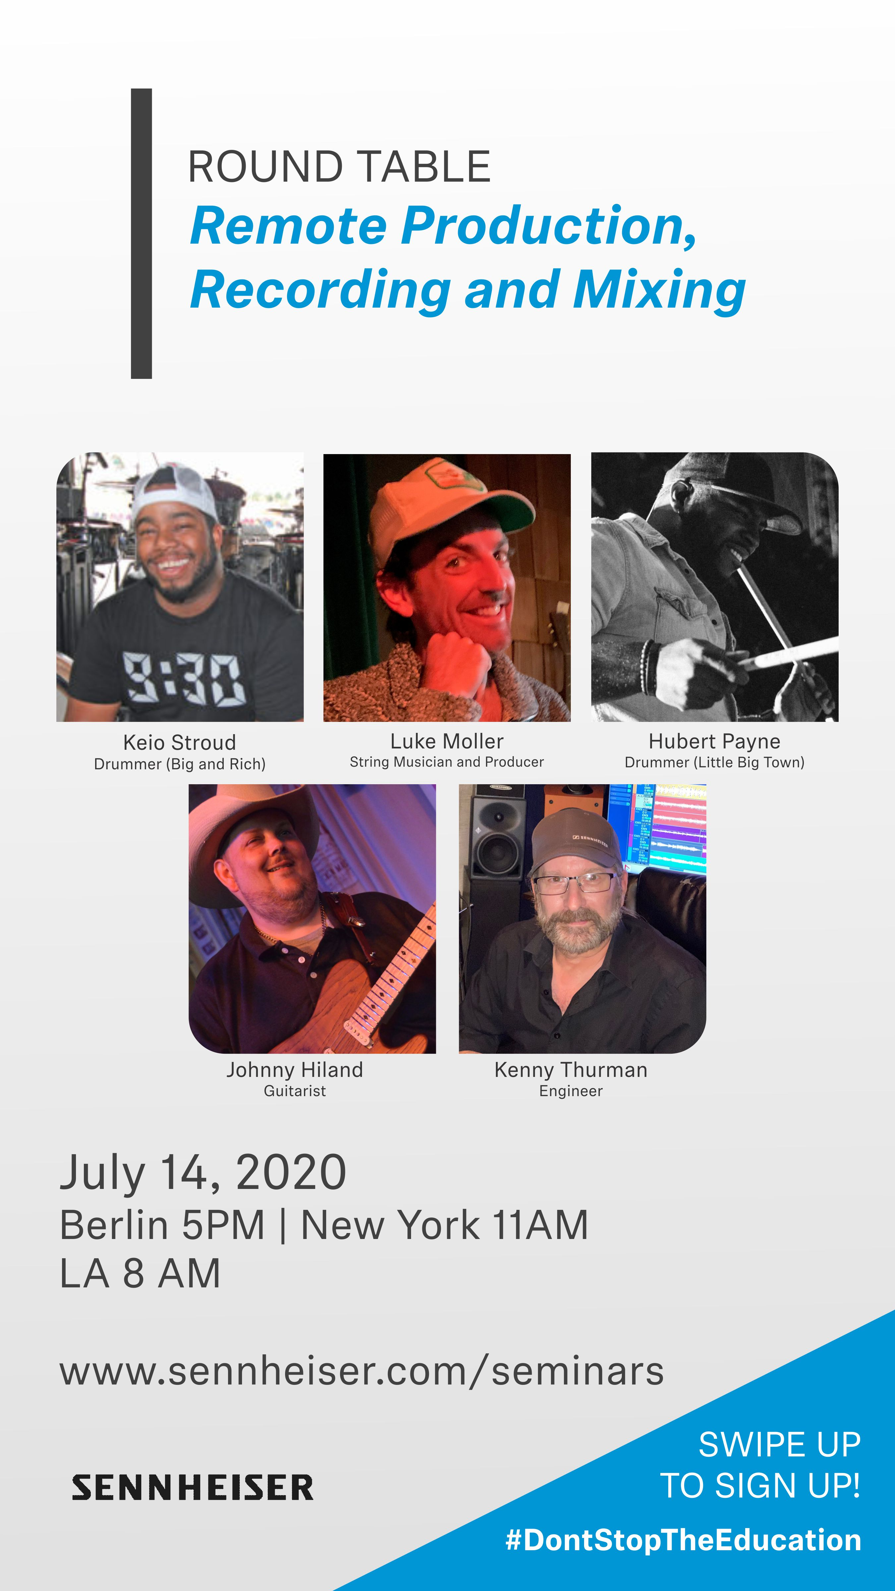

Please visit https://www.sennheiser.com/seminars for a full, up-to-date list and to register free of charge for a SoundAcademy seminar of your choice. The free training sessions are often offered at several different times to allow as many people from around the globe to tune in as possible.

About Sennheiser
Founded in 1945, Sennheiser is celebrating its 75th anniversary this year. Shaping the future of audio and creating unique sound experiences for customers – this aim unites Sennheiser employees and partners worldwide. The independent family company, which is managed in the third generation by Dr. Andreas Sennheiser and Daniel Sennheiser, is today one of the world’s leading manufacturers of headphones, loudspeakers, microphones and wireless transmission systems. In 2019, the Sennheiser Group generated turnover totaling €756.7 million. www.sennheiser.com

Global Press Contact

Stephanie Schmidt
Stephanie.schmidt@sennheiser.com
+49 (5130) 600 – 1275

